**Answer 1**

**Misclassification Impurity:** 1 - max(probability of point in a class)

**Gini Impurity:** 1 - summation of (probability of point in a class)2

**Entropy Impurity:** - (summation of (probability of point in a class * log (probability of point in a class)))

1. There are 3 blue and 2 red data points. Total = 5  
   P(Blue) = 3/5 = 0.6, P(Red) = 2/5 = 0.4

Misclassification Impurity: 1 – max(0.6, 0.4) = 1 – 0.6 = 0.4

Gini Impurity: 1 – [(0.6)2 + (0.4)2] = 1 – (0.36+0.16) = 1 – 0.52 = 0.48

Entropy Impurity: - (0.6 * log2 0.6 + 0.4 * log2 0.4) = - ((-0.442) + (-0.529)) = 0.97

1. There are 2 blue and 3 red data points. Total = 5  
   P(Blue) = 2/5 = 0.4, P(Red) = 3/5 = 0.6

Misclassification Impurity: 1 – max(0.4, 0.6) = 1 – 0.6 = 0.4

Gini Impurity: 1 – [(0.4)2 + (0.6)2] = 1 – (0.16+0.36) = 1 – 0.52 = 0.48

Entropy Impurity: - (0.4 * log2 0.4 + 0.6 * log2 0.6) = - ((-0.529) + (-0.442)) = 0.97

There is no difference in the Impurity calculations for the 2 cases.

**Answer 2**

The bootstrap procedure is used to create multiple datasets by using sampling techniques with replacement for the selected rows from the original dataset. Each of this sampled dataset τ* will be used to train a decision tree.

The out-of-bag error estimator helps in estimating the performance without using a test set. It considers the rows from the original dataset τ that were not sampled as the test set. On average, a datapoint has the probability of 1/e for not being selected for the sampled dataset where e = 2.71828

P(Not Selected) = 1/e = 1/2.71828 = 0.3678, P(Selected) = 1 - 1/e = 0.632

Total number of datapoints = n

The probability of selecting a data point from n points = 1/n

The probability of not selecting a data point from n points = (1 - 1/n)

If we are going to sample the data points n times, then the probability for the data point not to be selected is (1 – 1/n)n

As the value of n approaches infinity, we can that

Lim n -> ∞ (1 – 1/n)n  = 1/e = 0.3678

This means that 36.78% of the points will be not be selected. i.e. ~0.37n data points will not be selected out of n available data points.

**Answer 3**

**(Code Attached in Appendix)**

We will be choosing the value of m that gives the highest R2 value. The idea is that a higher R2 value means that the independent variables will more likely explain the variance of the dependent variable.

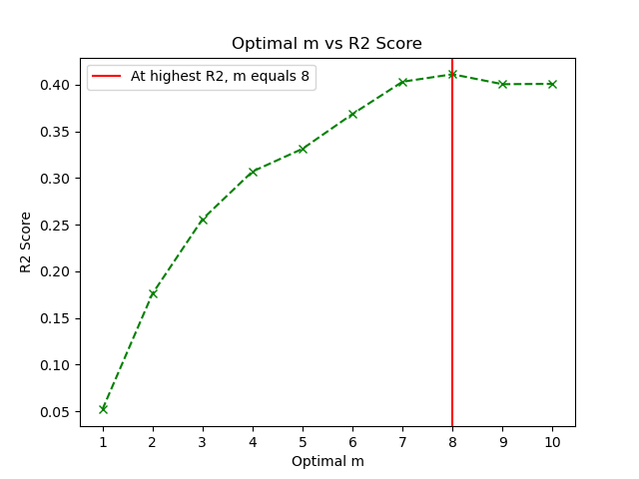

From the plot, we can see that the value of **m = 8** when R2 is the highest with a **R2****score of 0.411193**

**Answer 4**

**(Code Attached in Appendix)**

Our objective is to choose the value of the gamma (γ) that minimizes the zero-one loss. After training the models on different values of gamma and plotting the data

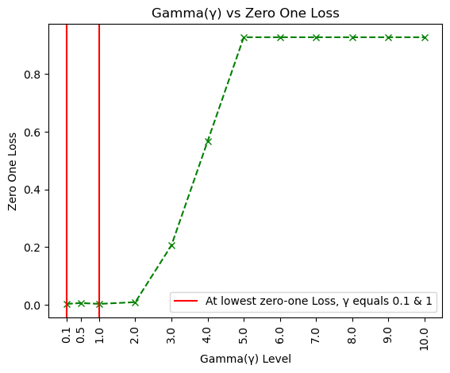

We can see that when the value of gamma increases the zero-one loss also increases. A value of gamma from 0.1 to 2 does not affect the zero one loss much. After gamma of level 2, we can see that the zero-one loss increases sharply with a gamma level of 5-10 having close to value of 1 zero-one loss.

Therefore, **Gamma level of 0.1 and 1 produces the lowest zero-one loss value of 0.003030**

**Answer 5**

1. After loading the dataset, the columns – [League, Division, NewLeague] were found to be having categorical values. The LabelEncoder was used to convert categorical value into numeric value. **(Code Attached in Appendix)**

|  |  |
| --- | --- |
| Division | |
| Original Value | Encoded Value |
| W | 1 |
| E | 0 |

|  |  |
| --- | --- |
| League | |
| Original Value | Encoded Value |
| N | 1 |
| A | 0 |

|  |  |
| --- | --- |
| NewLeague | |
| Original Value | Encoded Value |
| N | 1 |
| A | 0 |

1. Label encoder and one-hot encoder both help in converting the categorical values into numbers.

* **One-hot encoding increase the dimensionality of the dataset.** Especially when the number of unique values in the column are very large. It creates a separate column for each unique value in the column.
* **Label encoder, therefore, is memory efficient as well as simple to interpret** as multiple columns are not created.
* If the column has some order or sequence among its unique values, this **order is also maintained when label encoder is used**

1. PCR is sensitive to range of the values defined in the column. We will use standardization techniques to transform the values into the range of 0 to 1. After the values have been standardized, we will loop through and keep on increasing the value of the number of components. From the plotted graph we can see a up-down graph with when 3 components are selected the MSE score is the highest. When 18 components are selected from a possible of 20 the cross validation MSE score is the lowest. **(Code Attached in Appendix)**

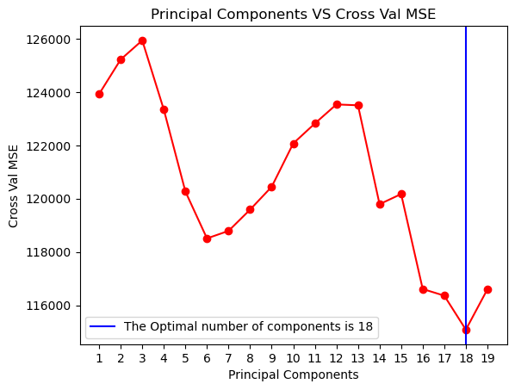

**Hence, the optimal number of components is 18 with a MSE of 115083.911541.**

1. First, we produce a list of desired lambda values. After that we train a lasso model based on different values of lambda. From the plot, we can see that at a lambda value of 120 the MSE calculated using cross validation is the lowest.

**(Code Attached in Appendix)**

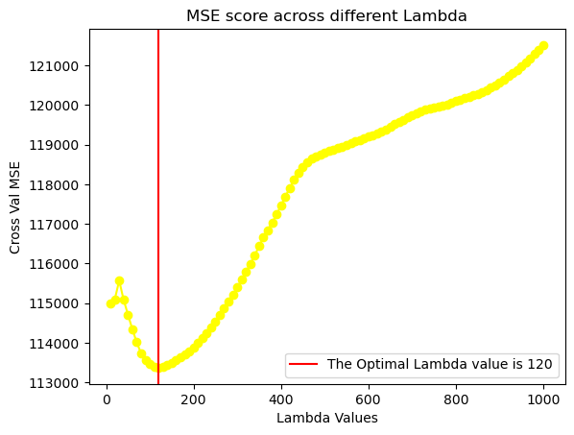

**Hence, the optimal Lambda(λ) value is 120 with a MSE of 113366.615176**

**Answer 6**

1. **(Code Attached in Appendix)**

The statsmodels.api module is used to create a Poisson Regression model.

|  |  |  |  |
| --- | --- | --- | --- |
| Feature | Coefficients | Lower Limit | Upper Limit |
| type | -0.223703 | -0.317121 | -0.130284 |
| construction | 0.371445 | 0.254601 | 0.488289 |
| operation | 0.767995 | 0.566527 | 0.969464 |
| months | 0.000081 | 0.000075 | 0.000087 |

1. 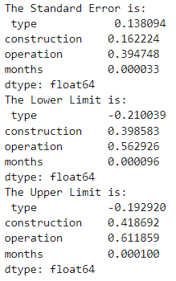**(Code Attached in Appendix)**

The value of standard error, lower limit and upper limit keeps on changing as the rows are sampled with replacement and no random state can be set. The value of the Confidence Intervals for the Poisson Regression Model and the Bootstrapped Model are different. The bootstrapped model’s confidence interval seems tighter and may provide a better insight.

**Answer 7**

1. The statsmodels.api module is used to create a Multiple Regression model.

**(Code Attached in Appendix)**

No constant was added to the dependent variables –

**Fitted model:** Time = ( 1.7079018042014529 * Cases ) + ( 0.01611513146598973 * Distance )

**Residual Standard Deviation:** 3.323160419363028

**P-values:**

Cases 1.577509e-09

Distance 2.950177e-04

1. **(Code Attached in Appendix)**

Residual Plots were created for both independent variables – Cases and Distance using the statsmodels.api module

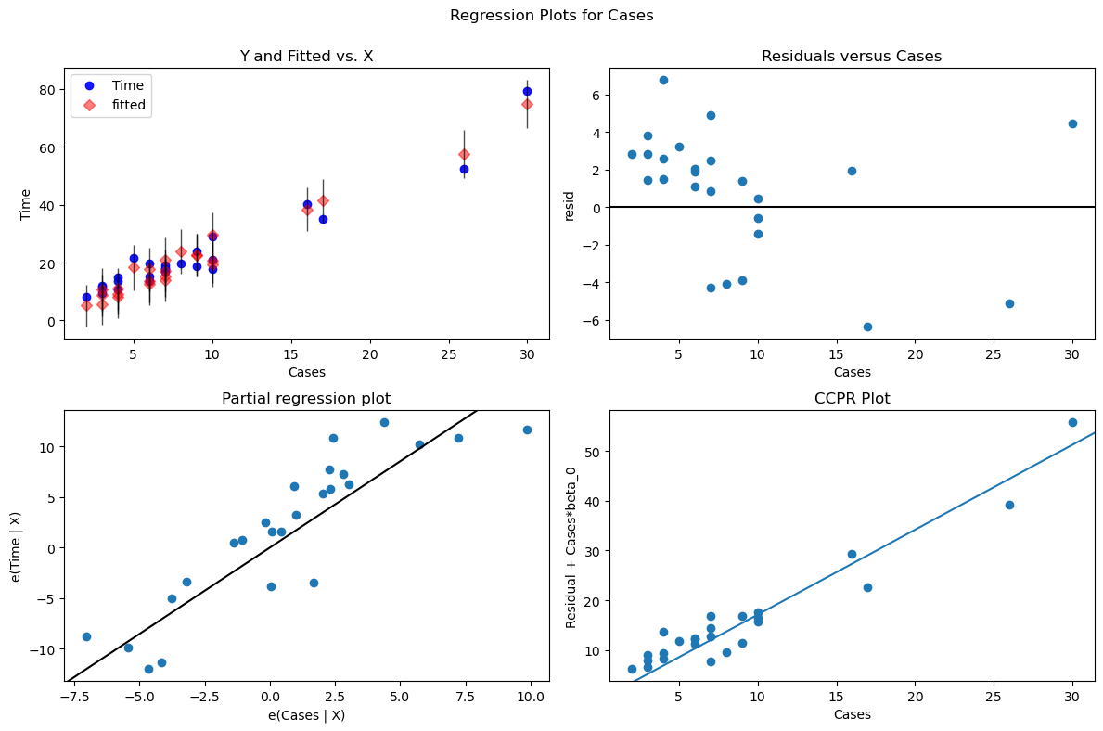

From the residual plot created for the independent variable “Cases”, we can see that in -

* **Y and Fitted vs. X** – From the graph we can see that the predicted values match very closely to the original values. As the fitted values are aligned closely to the original values along a diagonal line means that the model performance is good in making predictions. The scattered pattern of points explains the variability of the system.
* **Residuals versus Cases plot** – This plot is used to check the goodness of fit. The optimal solution is that the residuals which is the difference between original value and fitted value should be distributed around 0 randomly. Clearly, we can see that the points are clubbed and we do not observe a spread across the different values of “Cases”. This is a case of Homoscedasticity as the spread is not ideal through the graph. This means that outliers affect the regression model.
* **Partial Regression Plot –** The graph defines the relation between the selected independent variable and dependent variable. From the graph, we can see a positive linear relationship between the dependent and independent variable. The individual data points are scattered along the diagonal black line but presents cases of variability meaning that other factors also affect the relationship between the two variables.
* **CCPR Plot –** It helps in understanding the relationship between the independent and dependent variable. From the graph, we can see an upward trend. For a larger value of the residual, the number of cases also increases. The closeness of the data points to the line suggests that significant variation in residuals is explained by Cases.

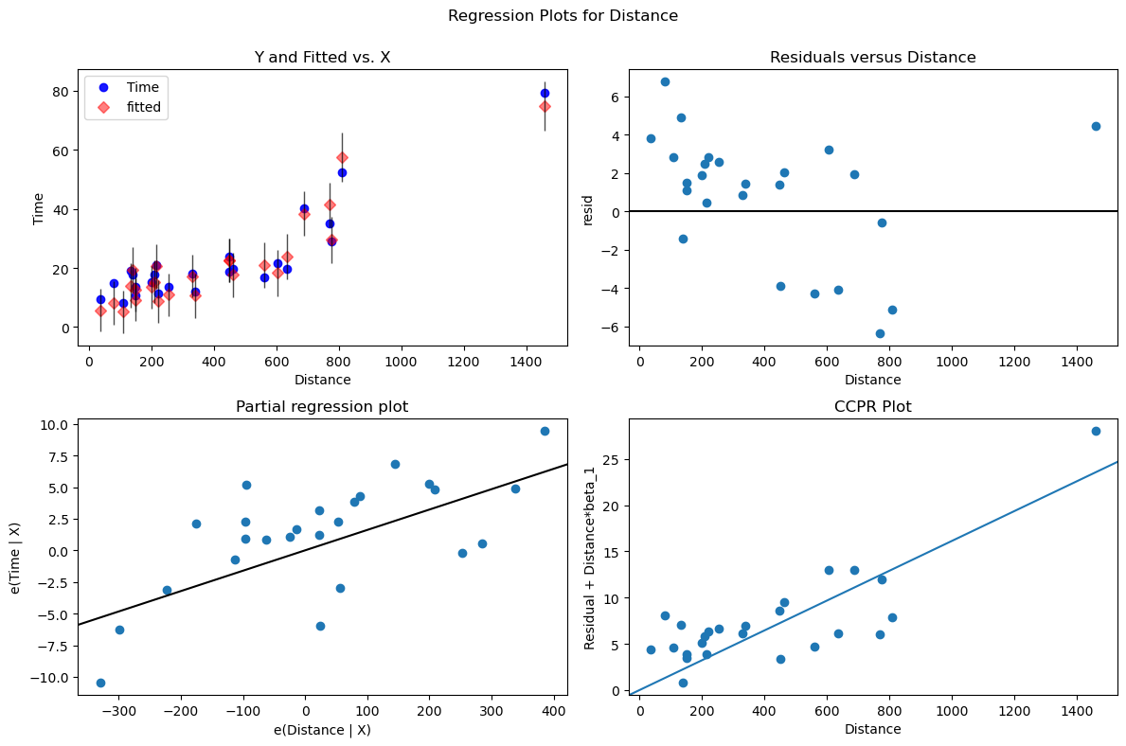

From the residual plot created for the independent variable “Distance”, we can see that in -

* **Y and Fitted vs. X** – From the graph we can see that the predicted values match very closely to the original values. As the fitted values are aligned closely to the original values along a diagonal line means that the model performance is good in making predictions. The scattered pattern of points explains the variability of the system.
* **Residuals versus Distance plot** – This plot is used to check the goodness of fit. The optimal solution is that the residuals which is the difference between original value and fitted value should be distributed around 0 randomly. Clearly, we can see that the points are clubbed and we do not observe a spread across the different values of “Distance”. The spread of residuals is also not ideal above and below 0. This is a case of Homoscedasticity as the spread is not ideal through the graph. This means that outliers affect the regression model.
* **Partial Regression Plot –** The graph defines the relation between the selected independent variable and dependent variable. From the graph, we can see a positive linear relationship between the dependent and independent variable. The individual data points are scattered along the diagonal black line but presents cases of variability meaning that other factors also affect the relationship between the two variables.
* **CCPR Plot –** It helps in understanding the relationship between the independent and dependent variable. From the graph, we can see an upward trend. For a larger value of the residual, the number of Distance also increases. One of the points at the very top can be identified as an outlier. The closeness of the data points to the line suggests that significant variation in residuals is explained by Distance.

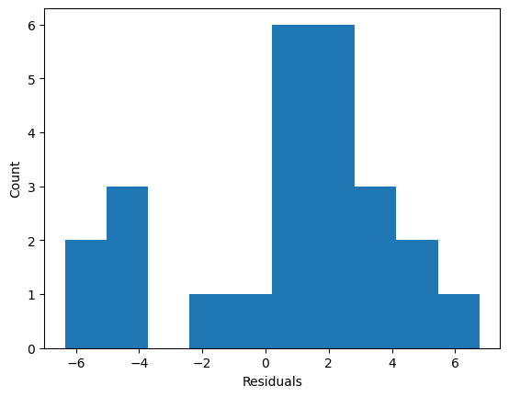

From the histogram, we can see that the plot is not perfectly symmetrical and shows some skewness. In an ideal case, the distribution should be normal with mean around 0. But in our case twin peaks appears suggesting a Bimodal distribution.

1. **(Code Attached in Appendix)**

Using cooks Distance, **the most influential observation is observation number 21**. From the graph below we can see that observation **8 and 19 are next most influential observations**

